ANSHIKA SRIVASTAVA

SAP ID – 500107049

BATCH – B1 HONS.

LAB EXPERIMENT - 2

**Advanced Python Programming Concepts and Operations**

Q1) Create and access tuples.

o Create a tuple of colors.

o Access elements using indexing.

o Try to modify an element in the tuple (to demonstrate immutability).

o Find the number of occurrences of a specific element in the tuple.

**Code –**

colors = ("Red", "Violet", "Magenta", "Yellow", "Green", "Red","Black")

print("First color:", colors[0]) #indexing

print("Last color:", colors[-1])

print("Showing that tuple is immutable")

colors[3]="white"

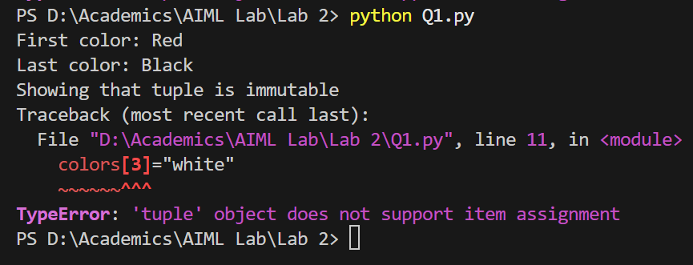

For number of occurrences of specific element –

red_count = colors.count("Red")

print("Number of times 'red' appears:", red_count)

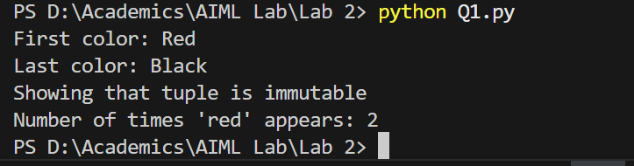

Q2) Create and manipulate dictionaries.

* + Create a dictionary to store information about a person (name, age, city).
  + Access values using keys.
  + Add a new key-value pair to the dictionary.
  + Modify an existing value.
  + Check if a key exists in the dictionary.
  + Get a list of all keys and values.

**Code –**

person = {

"name": "Anshika",

"age": 20,

"city": "Lucknow"

}

print("Accessing values using keys")

print("Name:", person["name"])

print("Age:", person["age"])

print("City:", person["city"])

print("\nAdding new key value pair")

person["email"] = "anshikasrivastava561@gmail.com"

print("Updated dictionary with email:", person)

print("\nModifying existing value")

person["age"] = 21

print("Modified age:", person)

print("\nChecking if key exists")

if "city" in person:

print("Key 'city' exists in the dictionary")

print("\nList of all keys and values")

keys = person.keys()

values = person.values()

print("Keys:", list(keys))

print("Values:", list(values))

Output –

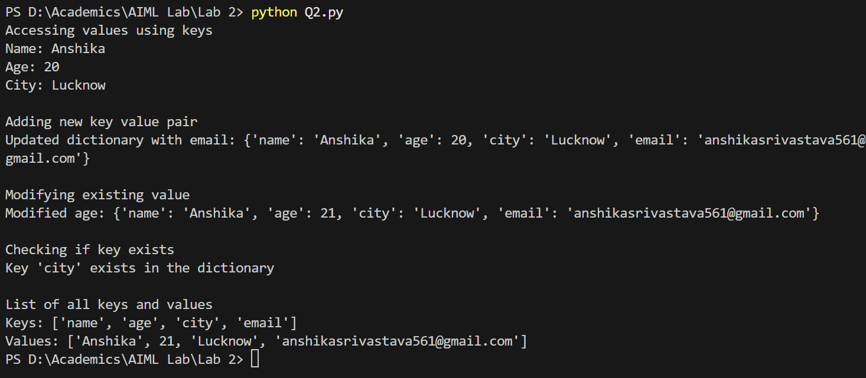

Q3) Demonstrate the difference between mutable and immutable data types.

o Create a list and a tuple.

o Try to modify an element in both the list and the tuple.

o Observe the results and explain the difference.

**Code –**

list = [1, 2, 3, 4, 5]

tuple = (6, 7, 8, 9, 10)

list[2] = 10

print("Modified list:",list)

try:

tuple[2] = 10

except TypeError as e:

print("Error:", e)

print("Original tuple:", tuple)

Output –

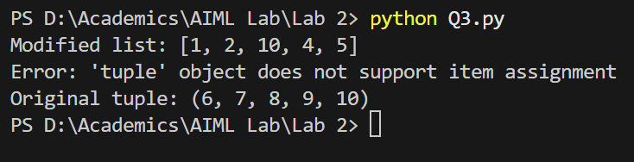

Lists in Python are mutable, which means their elements can be changed after creation.

Here, the value at index 2 in the list (3) is successfully updated to 10.

Tuples in Python are immutable, meaning their elements cannot be changed after creation.

When we attempt to modify the element at index 2 in the tuple, Python raises a TypeError to indicate that tuples do not support item assignment.

Q4) Create a program to print the multiplication table of a number.

o Take a number as input from the user.

o Use a for loop to iterate from 1 to 10.

o Calculate the product of the input number and the current iteration.

o Print the multiplication table.

**Code –**

number = int(input("Enter a number to print its multiplication table: "))

for i in range(1, 11):

product = number * i

print(f"{number} x {i} = {product}")

Output –

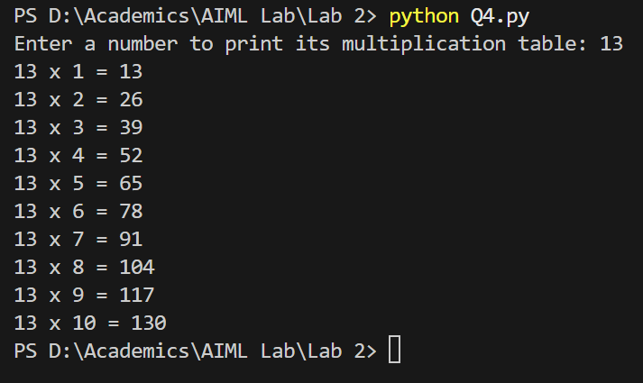

Q5) Create a program to find the factorial of a number using a loop and conditional statements.

**Code –**

number = int(input("Enter a number to find its factorial: "))

if number < 0:

print("Factorial is not defined for negative numbers.")

elif number == 0:

print("Factorial is 1")

else:

result = 1

for i in range(1, number + 1):

result *= i

print("Factorial of the number",number,"is",result)

Output –

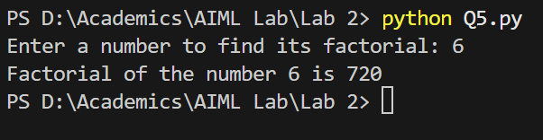

Q6) Write a program to check if a given number is prime.

**Code –**

number = int(input("Enter a number to find if prime or not: "))

count = 0

for i in range(1,number+1):

if(number%i==0):

count=count+1

if(count==2):

print("The given number",number,"is prime")

else:

print("The given number",number,"is not prime")

Output –

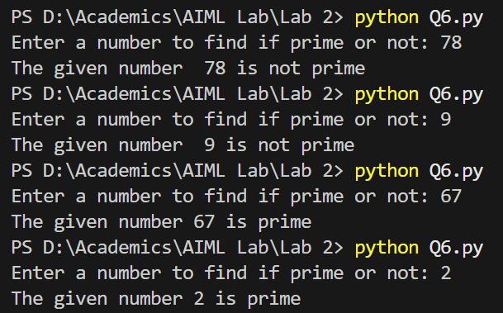

Q7) Create a program to find the sum of all even numbers between 1 and 100.

**Code –**

sum = 0

for i in range(1,101):

if(i%2==0):

sum = sum + i

print("Sum of all even number between 1 and 100 is",sum)

Output –

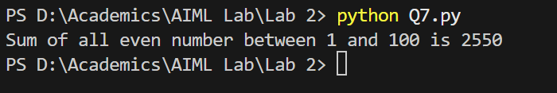

Q8) Implement a simple calculator using conditional statements and loops.

**Code –**

while True:

num1 = float(input("Enter the first number: "))

num2 = float(input("Enter the second number: "))

print("Choose any operation:")

print("1. Addition (+)")

print("2. Subtraction (-)")

print("3. Multiplication (*)")

print("4. Division (/)")

print("5. Modulus (%)")

print("6. Exit")

choice = input("Enter your choice ")

if choice == '1':

print(f"The result of {num1} + {num2} is {num1 + num2}")

elif choice == '2':

print(f"The result of {num1} - {num2} is {num1 - num2}")

elif choice == '3':

print(f"The result of {num1} * {num2} is {num1 * num2}")

elif choice == '4':

if num2 != 0:

print(f"The result of {num1} / {num2} is {num1 / num2}")

else:

print("Error: Division by zero is undefined.")

elif choice == '5':

if num2 != 0:

print(f"The result of {num1} % {num2} is {num1 % num2}")

else:

print("Error: Modulus by zero is undefined.")

elif choice == '6':

print("Exiting the calculator")

break

else:

print("Invalid choice. Please select a valid operation.")

Output –

